Guide to Peer-Reviewed Sources
Reminder: In the Analysis section of the CT papers, you must cite at least 4 relevant sources that are peer-reviewed (listed in green below) and were published in the last 10 years. Failure to do so will result in a paper score of zero.
What classifies as a peer-reviewed publication?
- Articles from peer-reviewed (or scholarly) journals. For more information on this, visit: Differences between Scholarly Journals, Popular Magazines & Trade Publications
- Books (or text-books). For the purposes of this class, all books are considered peer-reviewed.
What does NOT classify as a peer-reviewed source?
- Newspapers and magazines. Reporters may not be experts in the field of the article. Thus, articles may contain incorrect information (ASU Library Services 2017).
- Newspapers and magazines containing articles written by academics or professionals. Although the articles are written by “experts,” the article may not have been reviewed by other experts in the field (ASU Library Services 2017).
  - Examples: National Geographic, New York Times, The Economist
- Websites. It does not matter if the website ends in .com, .org, .gov, .whatever – information on websites is not peer-reviewed. It may be fact-checked and reliable information, but it does not mean it underwent the peer-reviewed process. The information could be coming from a prestigious NGO (e.g., WWF, GreenPeace, Survival International, etc), and it may be accurate, but it does not mean it is peer-reviewed.
- Dissertations, theses, industry reports, NGO reports. These types of sources are often referred to as "grey literature." Again, these documents could contain valuable and reliable information, but they do not undergo the peer-reviewed process.
- Blogs. Some prestigious scholars might be great bloggers but blogs are not peer-reviewed. You can get ideas and inspirations from these, but do not cite them in a scholarly paper.
- Government reports or publications. These could be peer-reviewed, but this is not always the case and it varies by country. For this reason, it is best to assume that they are not peer-reviewed.
Note: You can cite sources that do not meet these criteria (listed in red below), but these can only be used as secondary sources, and in addition to the four primary sources.

IMPORTANT: If you are not certain whether a source you want to use is peer-reviewed or not, please contact your T.A. and have them approve (or disapprove) of the source before you submit your CT paper.

How to Find Peer-Reviewed Journal Articles through the OSU Library Website
This is how the OSU Library explains how to identify a peer-reviewed journal: "Peer-reviewed journals can be identified in several different ways: (1) Journals identify themselves as peer-reviewed (in the small print describing who they are in each issue, or on the publisher's website about the journal). (2) You can also do a search in several databases such as Academic Search Premier and limit your results to "Scholarly" or "peer-reviewed."
To find peer-reviewed publications in the OSU Library website:
- Go to http://osulibrary.oregonstate.edu/
- Type in key words related to the topic you are researching in the search bar.
It helps to play around with this, as you will get different results if you change some of these words. For example, you can type “sustainability of electric cars,” then try something like “benefits of electric vehicles,” “disadvantages of electric cars,” etc.
- IMPORTANT: Once you are on the page showing the results of your search, click on “Peer-reviewed Journals” located in the right-hand bar, under “Refine my results” (as shown by the red arrow below).
- After you check that box, click on “APPLY FILTERS.” This will ensure that all the search results you get classify as peer-reviewed sources.
- The peer-reviewed articles are clearly identified by a purple icon.
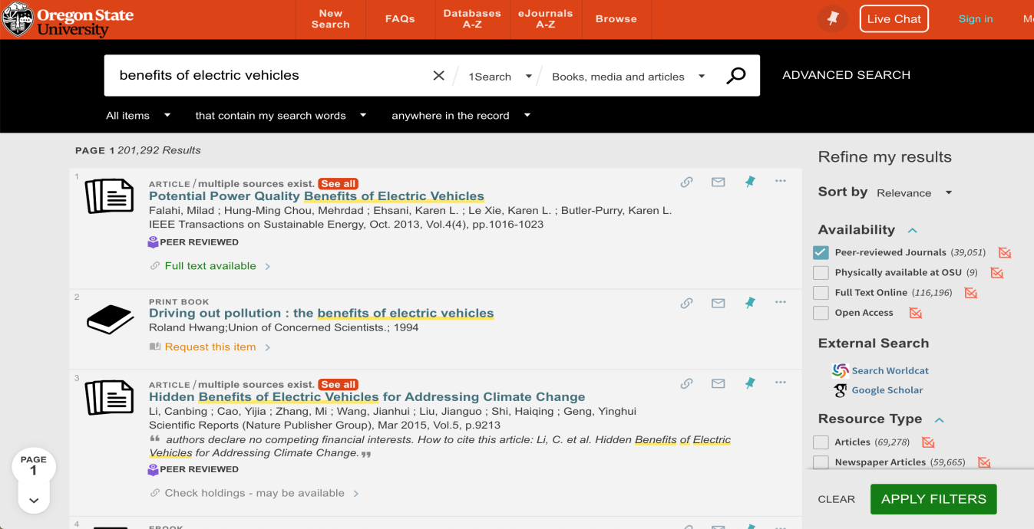

Alternative Search Engines
You can use other search engines and databases, such as Google Scholar, if you wish. But you must be careful when using it, as this database is not as clear about the quality of the results from your search. If you are not sure whether a source you found though Google Scholar is peer-reviewed, then do not use it as a primary source or double check that it is before doing so.

